**Lab 10**

**Interfacing an external LCD to the MSP430 Microcontroller and Onboard LCD**

Spring 2025

Submitted by: Mohsin Sajjad

Registration No: 22pwsce2149

Class Section: A

“On my honor, as student of University of Engineering and Technology, I have neither given nor received unauthorized assistance on this academic work.”



Student Signature: ______________

Submitted to:

Engr. Faheem Jan

Month Day, Year (18 05, 2025)

Department of Computer Systems Engineering

University of Engineering and Technology, Peshawar

**Interfacing an external LCD to the MSP430 Microcontroller and Onboard LCD**

TASKS:

1) Write Your Name on First Line and registration Number on second line of LCD (use proteus or attach external LCD with MSP).

CODE:

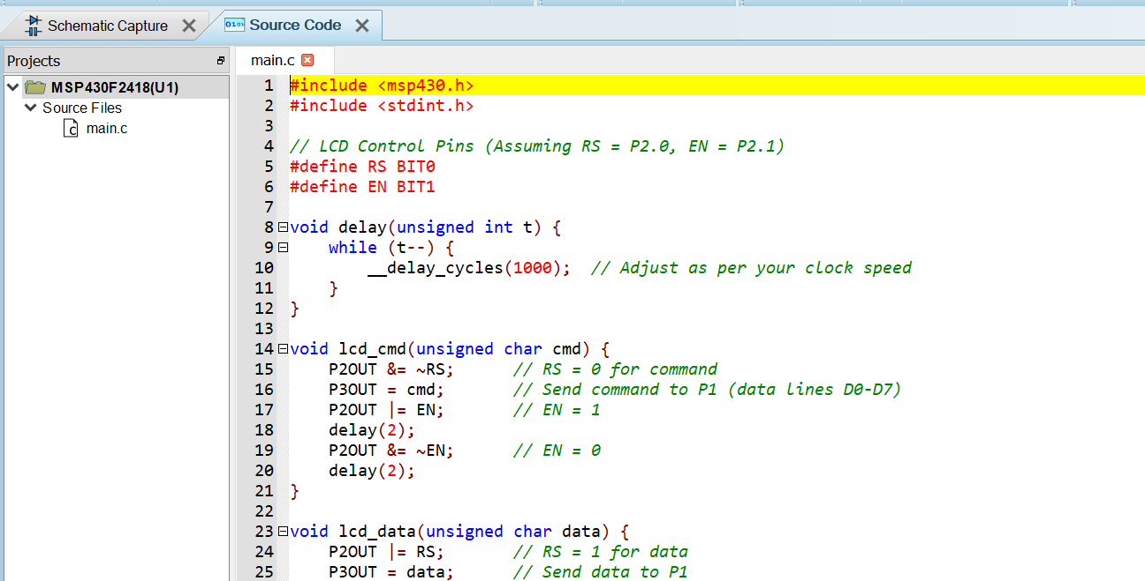

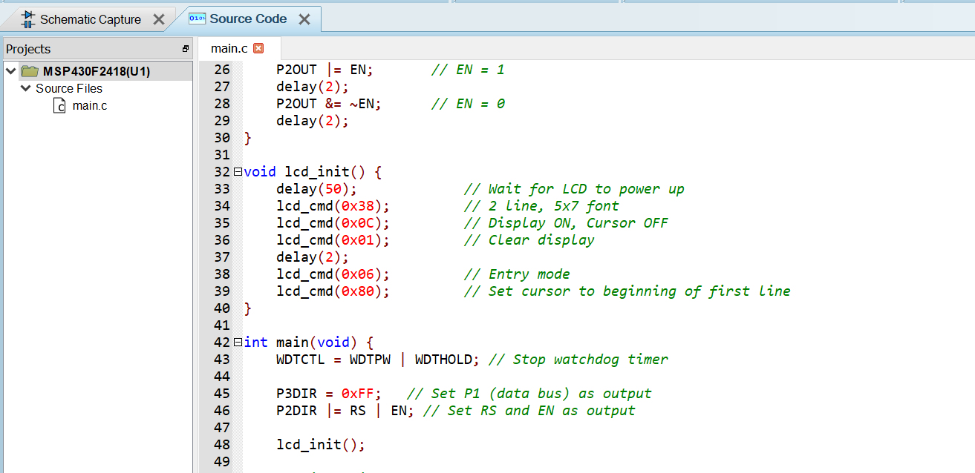

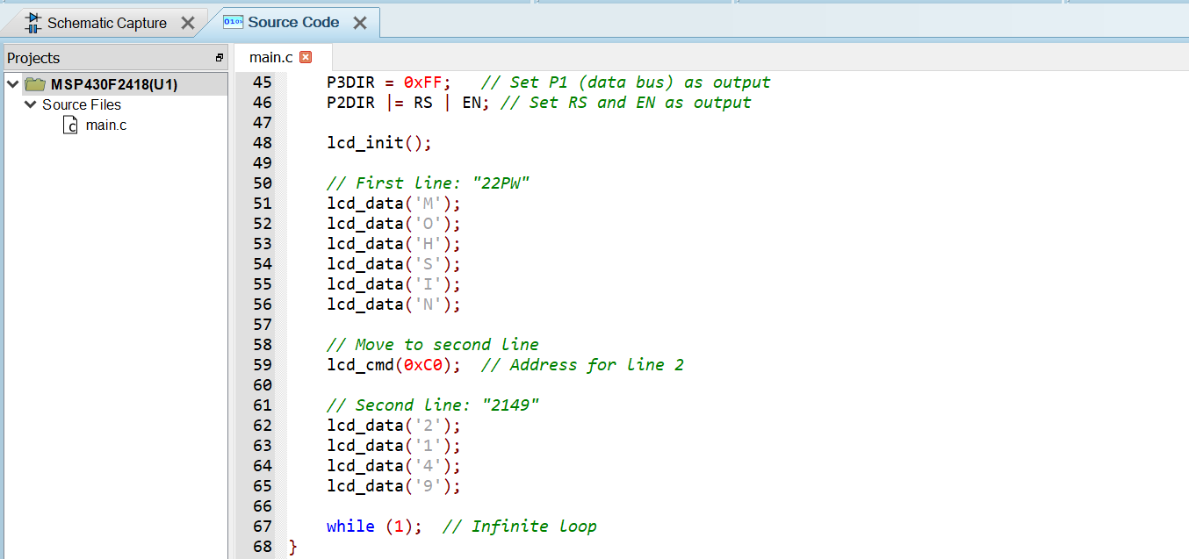

OUTPUT:

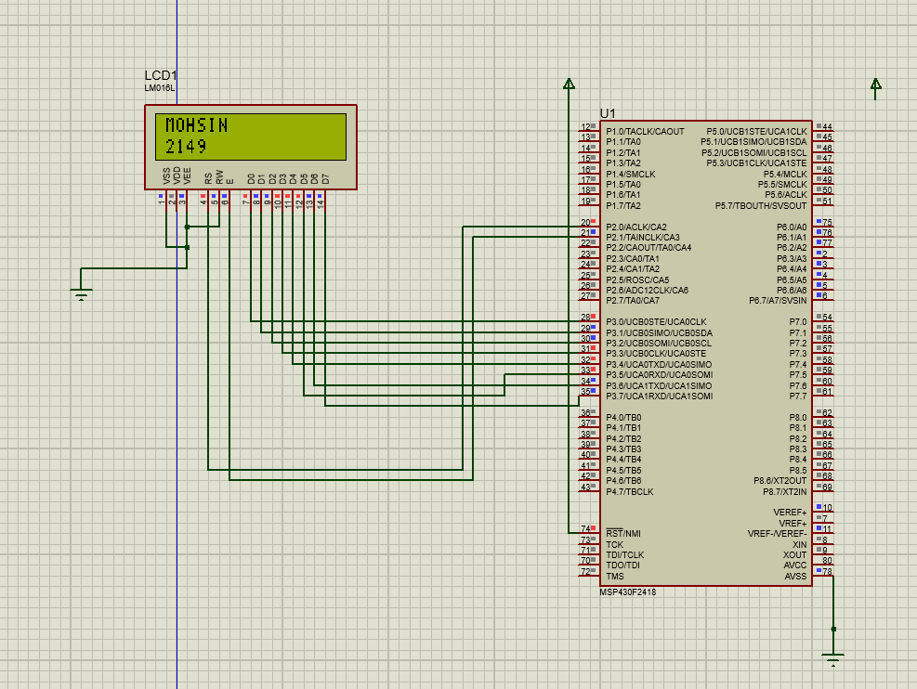

**Task 2:**

**CODE:**

Write last four digit of your registration Number On the Onboard LCD of msp430fr4133.



